1. **Agenda**:
   1. Spring Boot setup for Publisher.
2. 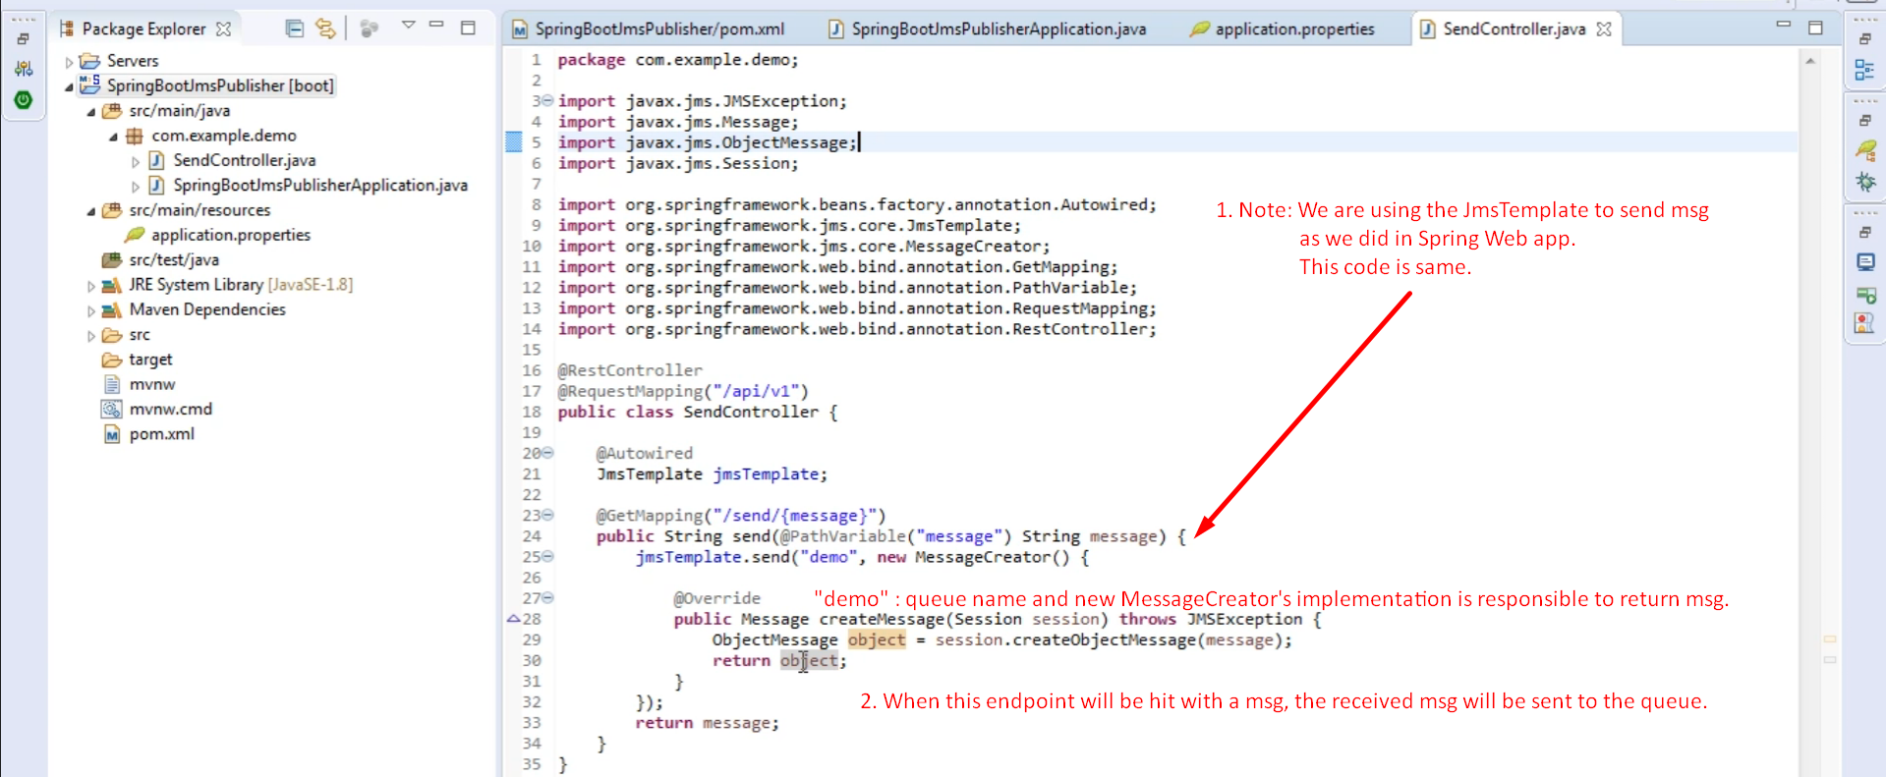
3. Graphical user interface, text, application, email

   Description automatically generated
4. Sending msg from browser  
   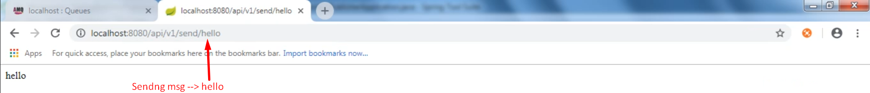
5. Graphical user interface, text, application

   Description automatically generated